EX.NO : 14

Date :24/11/20

**AIM:**

* To write a python program to find the validity of a string of parantheses.

**Program:**

def areBracketsBalanced(expr):

stack=[]

open_exp=['{','[','(']

for i in range(len(expr)):

if(expr[i] in open_exp):

stack.append(expr[i])

else:

if not stack:

return False

cur=stack.pop()

if(cur == '{' and expr[i]!='}'):

return False

if(cur == '[' and expr[i]!=']'):

return False

if(cur == '(' and expr[i]!=')'):

return False

if stack:

return False

else:

return True

if __name__ == "__main__":

expr=input()

if(areBracketsBalanced(expr)):

print("valid")

else:

print("invalid")

LINK:

<http://103.53.53.18/mod/vpl/forms/submissionview.php?id=327&userid=1669>

**Output:**

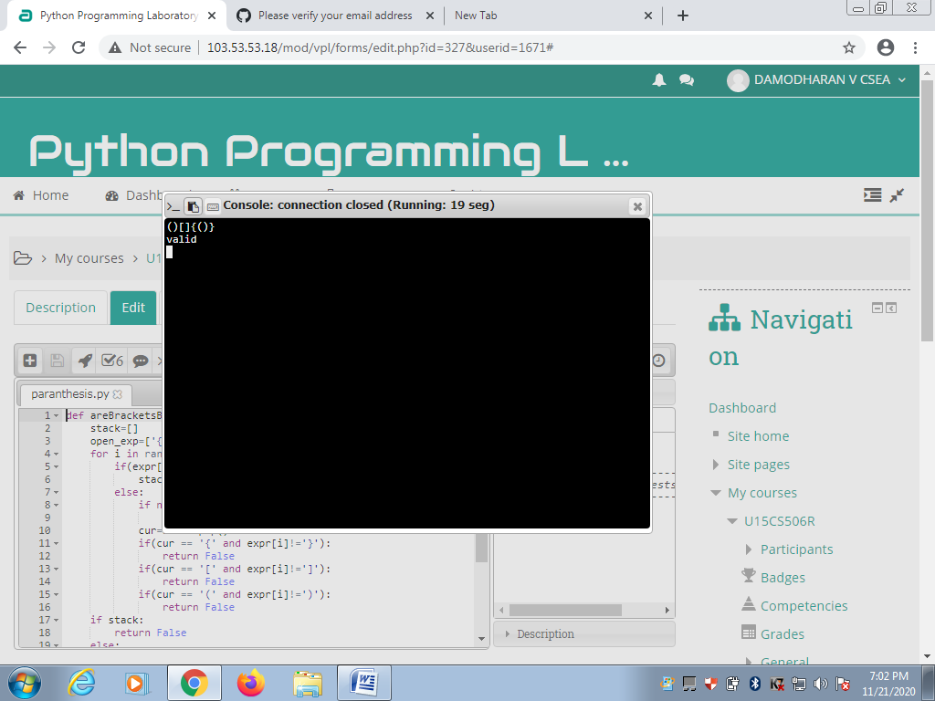

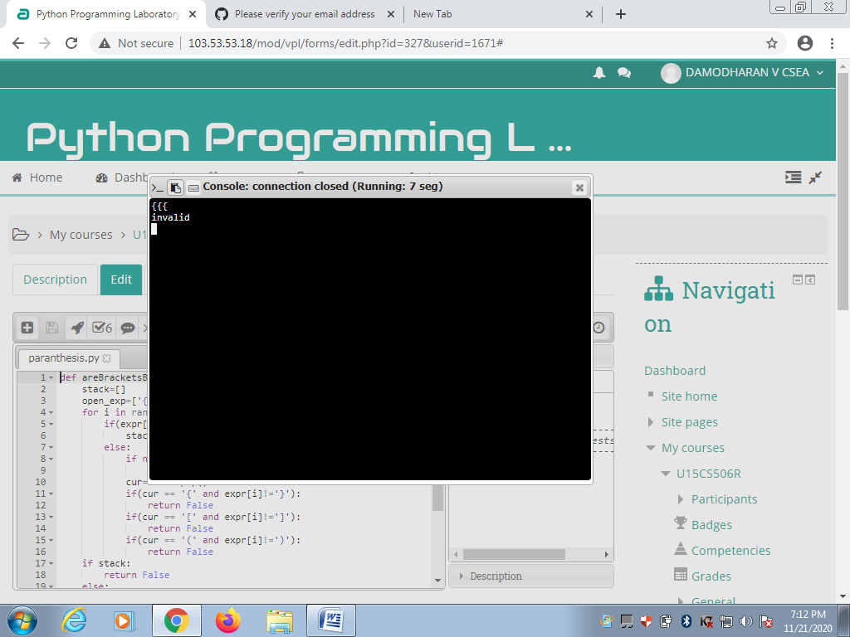

**Result:**

* Thus the program to find the validity of a string of parantheses is executed and the output is obtained.